DNNpwa-TL predict RT of compounds through transfer learning of a DNNpwa model. DNNpwa is a DNN model built on the METLIN small molecule retention time (SMRT) dataset containing 80038 small molecule compounds. (The SMRT dataset is available in: https://figshare.com/articles/dataset/The_METLIN_small_molecule_dataset_for_machine_learning-based_retention_time_prediction/8038913)

DNNpwa-TL was written in Python 3.6.12 (64 bit). The application programming interface of Keras 2.4.3 was used for building autoencoders and the DNN model. The packages of tensorflow 2.3.0, sklearn 0.24.1, rdkit 2018.09.3.0, pandas 1.1.5 and numpy 1.18.5 were used for building the environment of programming.

The structure of DNNpwa is shown in Figure 1. The keras-based interface of DNNpwa for transfer learning is shown in Figure 2. The model weight trained on the SMRT dataset is ‘DNN_weight.h5’ in the folder of ‘DNNpwa model weight’. To transfer the DNNpwa model, codes are shown in the following:

path = '…/DNN_weight.h5'  
model = fine_tune_SAE(X_train, path)  
model.fit(X_train_scale, y_train, epochs=num_epochs, batch_size=num_batch_size, verbose=0)  
predicts = model.predict(X_test)



Figure 1. Structure of DNNpwa.

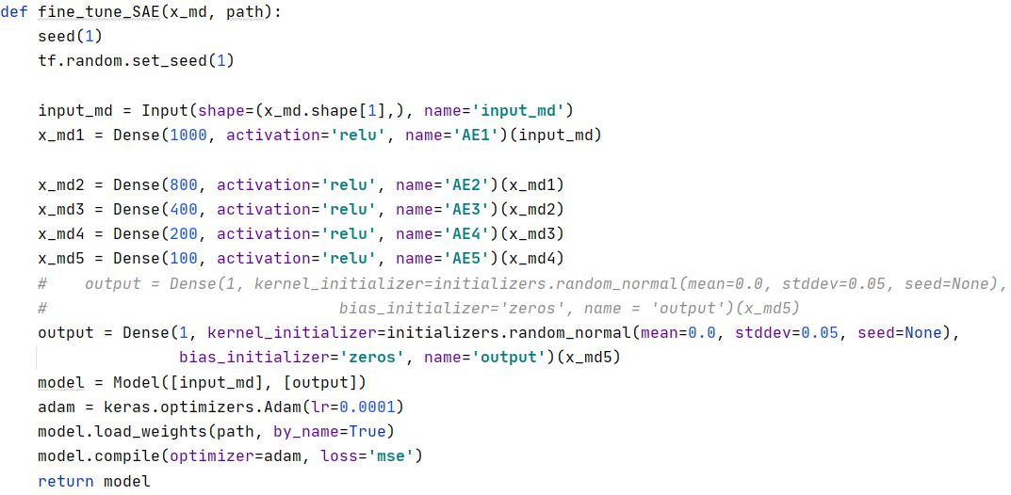

Figure 2. The keras-based interface of DNNpwa for transfer learning.